Brick Math
Pre-Algebra
Chapter Assessment Answer Key

Chapter 1

1. The distance a number is from zero is its absolute value.

2. Answers will vary. One example of -4 and +4 is shown. Make sure that the bricks clearly show negative and positive values placed the same distance from the center of the number line.
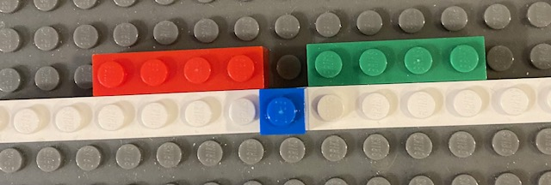
-4 0 +4

3. Answers will vary. One example of -4, +4, and |4|is shown. Make sure that the bricks clearly show negative and positive values placed the same distance from the center of the number line. Also be sure the absolute value is shown using the correct symbols.
-4 0 +4

Chapter 2

1. An integer is a whole number, and its value can be positive, negative, or zero.

2. The problem is +125 - 45.
Model both numbers using the place value method of modeling:
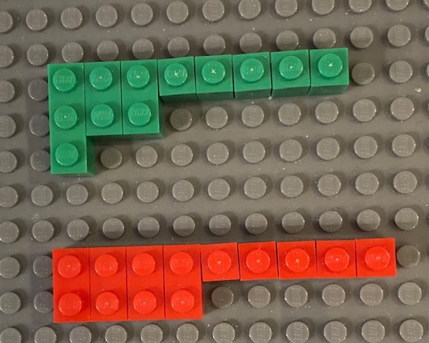

125

-45
Match all the zero pairs:
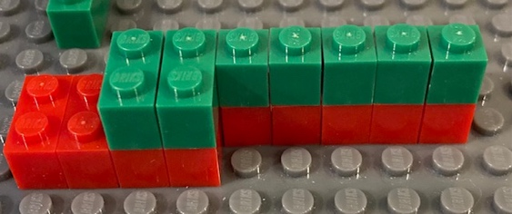

Remove the matched zero pairs:
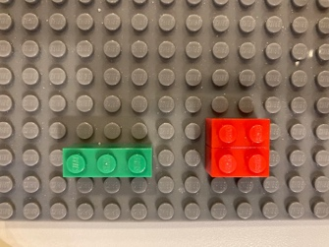

100

-20
Decompose the 100 into 10 tens:

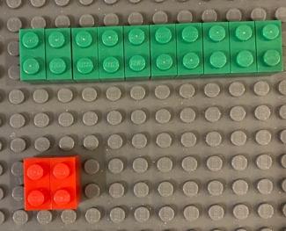
100

-20
Match all the zero pairs:
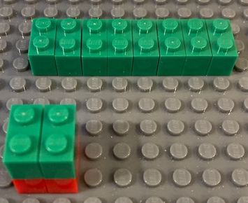
Remove the matched zero pairs:
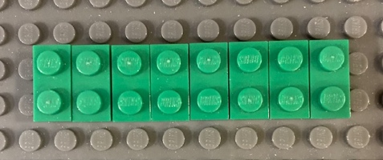

80
The solution to the problem is +80 yards. Martin ended the game with an overall gain of 80 yards, having lost 45 yards but gaining 125 yards.

3. Start with the brick at -4, then count up 20 to reach the solution at +16.
The temperature changed from-4 degrees to +16 degrees from Monday to Tuesday.

Chapter 3

1. The exponent in 3⁴ is 4. It means to multiply three 4 times (3 x 3 x 3 x 3)
The exponent in 5² is 2. It means to multiply five 2 times (5 x 5)
The exponent in 10⁴ is 4. It means to multiply ten 4 times (10 x 10 x 10 x 10)

2. 6⁴

3. 3 x 10² means 3 multiplied by the quantity (10 x 10), or 3 (10 x 10) = 3(100) = 300

Chapter 4

1. 3 x 10⁻² means 3 x 0.01 = 0.03
3 x 10² means 3 x (10 x 10) = 3 x 100 = 300
The negative exponent, -2, means that the decimal point is moved 2 places to the left of the ones place to convert from scientific to standard notation. The positive exponent, 2, means that the decimal point is moved two places to the right of the ones place to convert from scientific to standard notation.

2. Answers will vary. Example: The multiplicative inverse of -5 is the reciprocal of -5 or
-(1/5). When the two are multiplied together you will always get 1. (-5/1 x -1/5 = 5/5)

3. 2 x 10⁻⁴
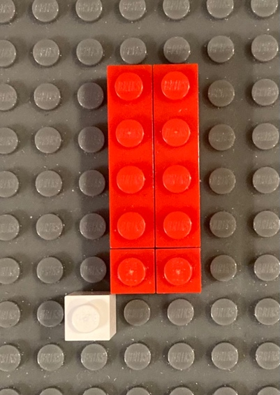
2 x 10⁻⁴ = 2 x (.0001) = 0.0002
2 x 10⁻⁴ = 2 x (1/10000) = 2/10000

Chapter 5

1. (-2) x 8 means taking away 2 sets of 8
Use zero pairs to remove negative numbers. Start with 2 zero pairs of 8. 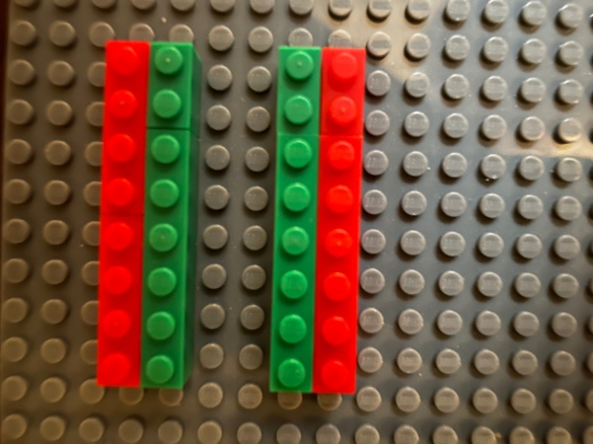

Then remove the two sets of 8, leaving 2 sets of -8, or -16.
2. a. positive
b. positive
c. positive
d. negative

Chapter 6

1. Monomial expressions have only one term. Binomial expressions have two unlike terms. Polynomial expressions have two or more of the same terms.

2. 2x² – x + 2:
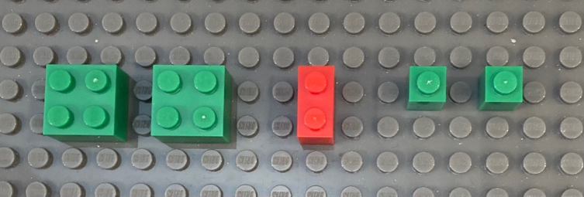
2x² - x + 2

3. a. Coefficients: 5 Variables: x Constants: 3 and 13
b. Coefficients: 3 and 2 Variables: x² and x Constants: -2 and 83

Chapter 7

1. 2x² - x² + y² + 2y - y + 1

2. 2x² - x² + y² - 2y + 2 - 1
Simplified: x² + y² – 2y +1

3. 3x2 - 2xy + xy - 3y2 + 5 - 2
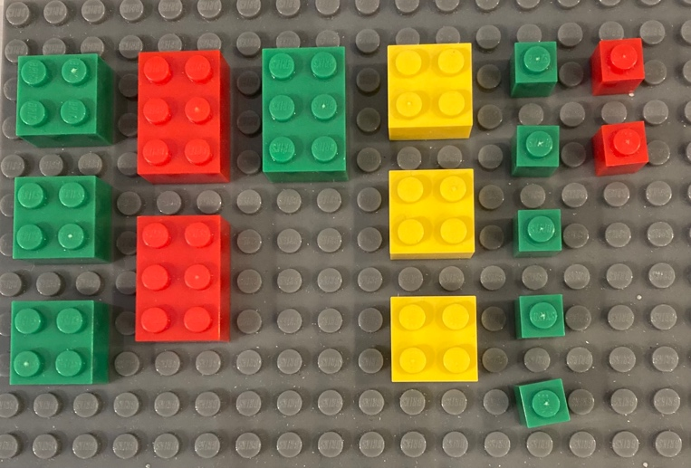
3x2 - 2xy + xy - 3y2 + 5 - 2
Simplified: 3x² - xy - 3y² + 3
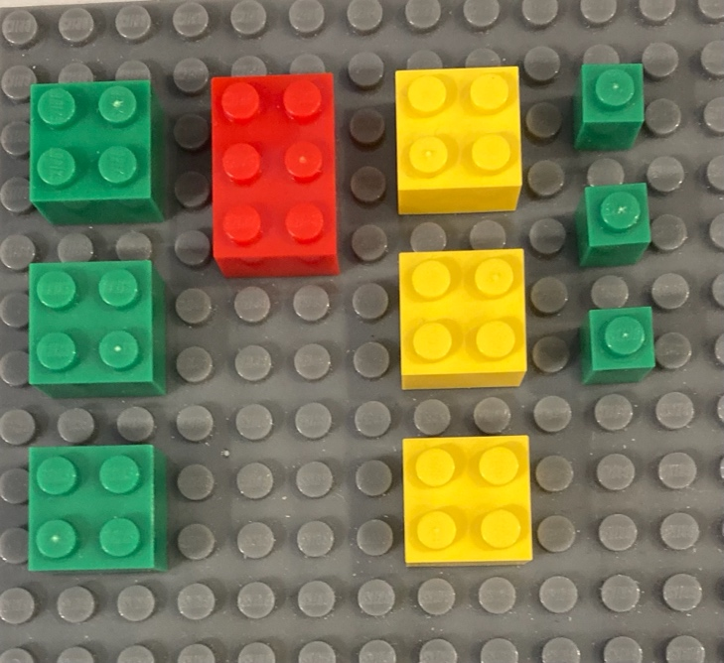
3x² - xy - 3y² + 3

Steps:
Combine like variables taking into account negative coefficients.
There are no x²s found after 3x² so 3x² stays.
One red and one green xy make a zero pair and are cancelled out, which leaves -xy.
There are no y²s found after -3y² so -3y² stays.
+5 and -2 make 2 zero pairs, leaving +3.

Chapter 8

1. Any number raised to the power of zero is 1, based on the zero-exponent rule.

2. 4⁻² = 1/(4)² = 1/16
This is based on the Negative Property of an exponent: Any non-zero number raised to a negative is the same as 1 over that number raised to that positive exponent.

3. 10² x 10⁶ = (10 x 10) x (10 x 10 x 10 x 10 x 10 x 10) = 100 x 1,000,000 = 100,000,000
This can also be shown by Product Property, which says that when multiplying exponential numbers that have the same base, add the exponents. 10⁽² ⁺ ⁶⁾ = 10⁸ = 100,000,000

4. 10⁴ ÷ 10² = (10 x 10 x 10 x 10) ÷ (10 x 10) = 10,000 ÷ 100 = 100
This can also be shown with the Quotient Property, which says that when dividing exponential numbers that have the same base, subtract the exponents. 10⁽⁴ ⁻ ²⁾ = 10² = 100

5. (3³)² = 3^{(3 x 2)} = 3⁶ = 3 x 3 x 3 x 3 x 3 x 3 = 729
This is based on the Power to a Power Property, which says that when raising an exponent to an exponent, multiply the exponents.

6. Rule 6 says that when the product of two numbers is raised to an exponent, distribute the exponent to each of those numbers and then multiply. For this example:
(-3 x 2)² = (-3)² x 2² = 9 x 4 = 36
This is the same as (-3 x 2)² = (-6)² = 36

7. Rule 7 says that when the quotient of two numbers is raised to an exponent, distribute the exponent to each of those numbers and then divide. For this example:
(6/2)² = 6²/2² = 36/4 = 9
This is the same as (6/2)² = 3² = 9

Chapter 9

1. 3x -2 < 8

2. Inequality is a mathematical expression that includes special signs to indicate which side is larger or smaller, or to show that the two sides are not equal.

3. Solutions will vary.

Chapter 10

1. -2x ≥ 24 - 6
Model:
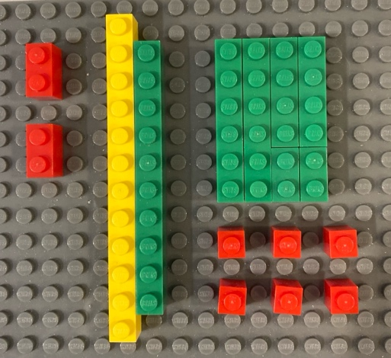

Match and remove zero pairs, leaving -2x ≥ 18
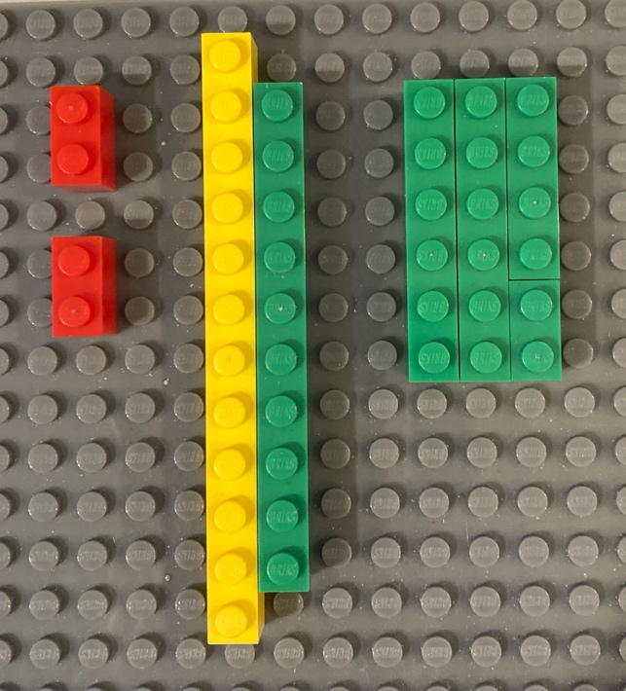

Divide bricks equally into two groups:
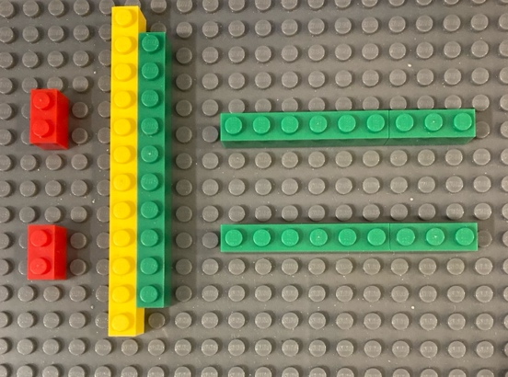

To eliminate the negative variable, create zero pairs for the x value. Add bricks that show 2x to both sides of the inequality:
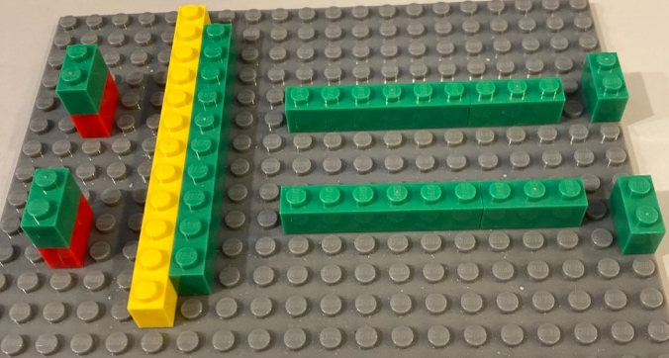

Remove the zero pairs. To isolate the x values on one side of the inequality, make zero pairs by adding -18 on both sides.
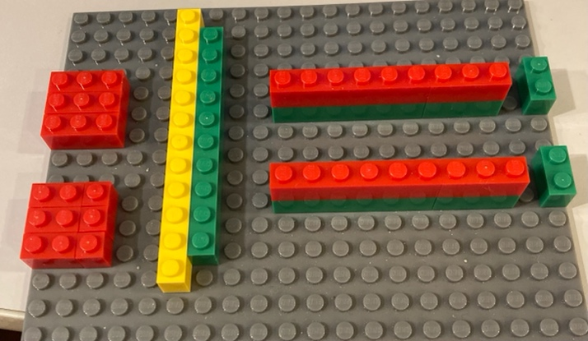

Remove the zero pairs.
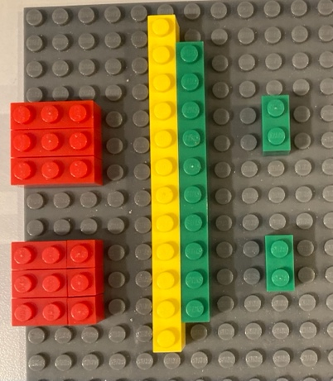
Flip the model to show the x value on the left. Reverse the sign of the inequality.
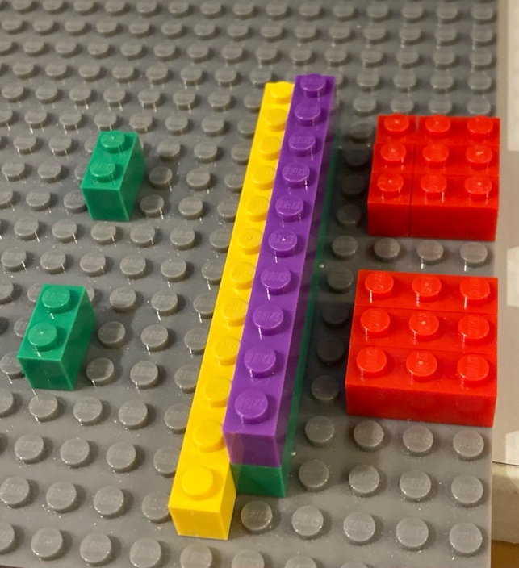

The model shows the solution of x ≤ -9

2. The rule for solving an inequality with a negative coefficient is to use the inverse operation to make the coefficient positive. When multiplying or dividing both sides of an inequality by a negative number, the sign must be reversed for the statement to hold true.

3. a. open circle
b. closed circle
c. closed circle

4. Solutions will vary. Responses should be similar to the complete solution for #1, with the addition of a number line graph that starts with a closed circle at -9 and moves left with values such as -10, -11, etc.

Chapter 11

1. Slope shows how much to change expect in y as x changes.

2. Slope is determined by rise over run. The values x₁, x₂, y₁, and y₂ are needed to calculate slope.

3. The slope is -½
The points shown are (0,3) and (4,1)
x₁ = 0 x₂ = 4 y₁ = 3 y₂ = 1

m = y₂ – y₁ = 1 - 3 = -2 -2/4 = -½
x_{2 –} x₁ = 4 - 0 = 4

