Brick Math

*Advanced Measurement and Geometry Using LEGO® Bricks*

Student Assessments Answer Key

**Chapter 1**

1. B (2S + 2S = P)

2. Answers will vary with drawing, but students should explain their thinking process for finding perimeter in one of two ways: (1) by adding all the side measures together, or (2) by first finding the length and doubling it, then finding the width and doubling it, then adding those two numbers together.

3. Perimeter measures the distance around the outside of a given shape.

4. 34 studs

Using one to one correspondence, students should count the studs on each side and add them together. (3 + 2 + 5 + 7 + 8 + 9 = 34)

**Chapter 2**

1. Area is the space that is taken up by the inside of a shape and is defined in units2.

2. L x W

3. S2 or L x W

4. Answers will vary depending on the shape. Students should show the length x width of the rectangle they create.

**Chapter 3**

1. Area and perimeter are different because perimeter is the distance **around** the shape and area is the amount of space **inside** the shape.

2. Decomposing a shape means dividing it into smaller and simpler parts, which are easy to determine measurements such as area and perimeter.

3. There are at least two common ways to create this model:

Option 1: create a 10 x 20-stud rectangle and divide the space within into three rectangular sections of 90 studs, 60 studs, and 50 studs

Option 2: create an 8 x 25-stud rectangle divide the space within into three rectangular sections of

88 studs, 64 studs, and 48 studs

Option 1 is shown.

The art area (blue) is 90 studs2.

The nap area (yellow) is 60 studs2.

The block center (red) is 50 studs2.

The model shows 200 studs in all.

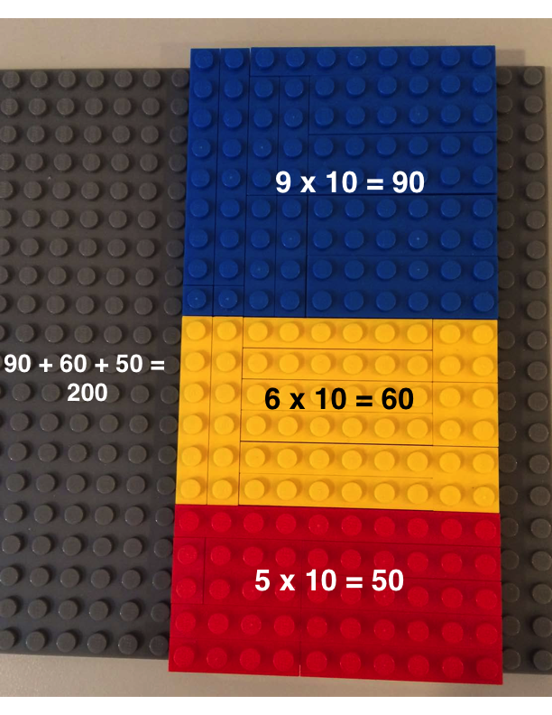

**Chapter 4**

1. When one dimension of a rectangle is changed, it will affect the area and perimeter. For example: if one length dimension of a rectangle is doubled, the area doubles.

2. There are several ways to model this problem. Three models are shown here.

Option 1: The first rectangle with perimeter of 20 has length = 6 and width = 4. Sides are 6 + 4 + 6 + 4 = 20. Area of this rectangle is 24 studs2. Doubling the length dimension to 12 gives a second rectangle with sides 12 + 4 + 12 + 4 = perimeter of 32. The area of this rectangle is 48 studs2, which is double the area of the first rectangle.

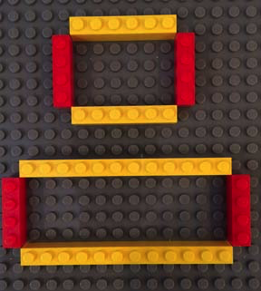

Option 2: The first rectangle with perimeter of 20 has length = 8 and width = 2. Sides are 8 + 2 + 8 + 2 = 20. Area of this rectangle is 16 studs2. Doubling the width dimension to 4 gives a second rectangle with sides 8 + 4 + 8 + 4 = perimeter of 24. The area of this rectangle is 32 studs2, which is double the area of the first rectangle.

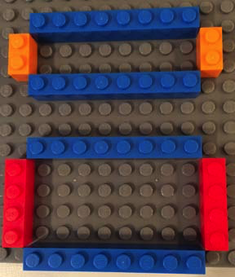

Option 3: The first rectangle with perimeter of 20 has length = 5 and width = 5. Sides are 5 + 5 + 5 + 5 = 20. Area of this rectangle is 25 studs2. Doubling the length dimension to 10 gives a second rectangle with sides 10 + 5 + 10 + 5 = perimeter of 30. The area of this rectangle is 50 studs2, which is double the area of the first rectangle.

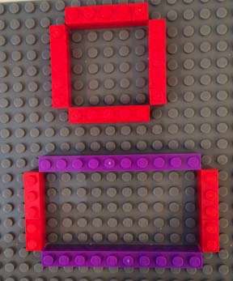

ALTERNATIVE MODELING TECHNIQUE:

Students could model the rectangle with corners. This illustration shows an alternative model for Option 3. The top 5-stud x 5-stud rectangle has perimeter of 20 (each corner stud is counted twice) and area of 25 studs2. The bottom 5-stud x 10-stud rectangle shows the length doubled to 10, with perimeter of 30 (each corner stud is counted twice) and area of 50 studs2.

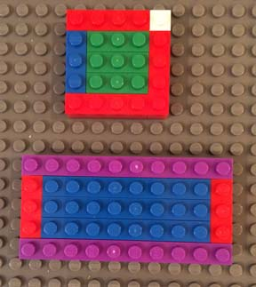

3. Side lengths of the original rectangle:

Side 1 = 6 studs

Side 2 = 8 studs

Side 3 = 6 studs

Side 4 = 8 studs

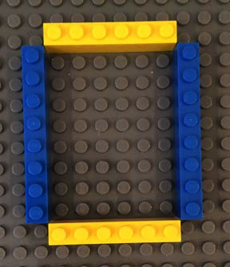

When the length dimension is cut in half, the new rectangle’s length is 4 studs and the width is 6 studs.

Side 1 = 4 studs

Side 2 = 6 studs

Side 3 = 4 studs

Side 4 = 6 studs

The area of the new shape (24) is half the area of the first shape (48).

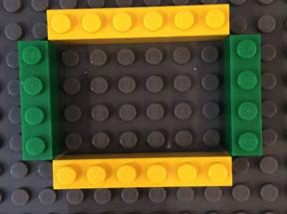

**Chapter 5**

1. A rectangular prism is a three-dimensional solid shape with 6 faces that are rectangles. It is also known as a cuboid.

2. Formula for Surface Area: SA = 2(L x W) + 2(L x H) + 2 (W x H)

3. Answers will vary based on how the four 2x4 bricks are stacked. A common option is for the bricks to be stacked as shown:

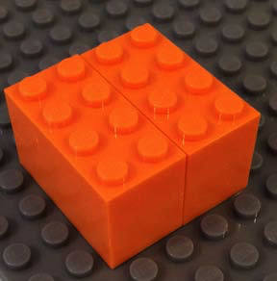

|  |  |  |  |  |  |
| --- | --- | --- | --- | --- | --- |
| Side | **Length** | **Width** | **Height** | **Formula** | **Area** |
| **1** | 4 studs | 4 studs |  | 4 x 4 | 16 studs |
| **2** | 4 studs | 4 studs |  | 4 x 4 | 16 studs |
| **3** | 4 studs |  | 2 studs | 4 x 2 | 8 studs |
| **4** | 4 studs |  | 2 studs | 4 x 2 | 8 studs |
| **5** |  | 4 studs | 2 studs | 4 x 2 | 8 studs |
| **6** |  | 4 studs | 2 studs | 4 x 2 | 8 studs |

Total 16 + 16 + 8 + 8 + 8 + 8 = 64 studs2

SA = 2(L x W) + 2(L x H) + 2 (W x H)

SA = 2(4 x 4) + 2(4 x 2) + 2(4 x 2)

SA = (2 x 16) + (2 x 8) + (2 x 8)

SA = 32 + 16 + 16 = 64 studs2

**Chapter 6**

1. Surface area of a 3-D shape refers to the area of all the outside faces added together. Volume of a 3-D shape refers to how much space is inside the shape, or how much the shape can hold.

2. The volume of most shapes can be found if you know the length, width, and height of the shape.

3. Rectangular prism made with three 2x6 bricks:

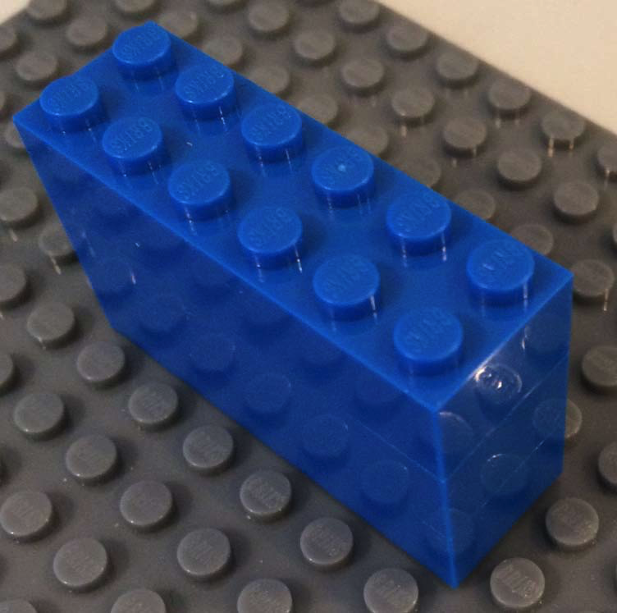

Separated layers of rectangular prism:

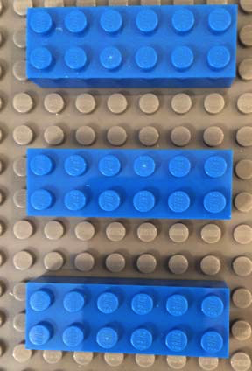

The volume of each layer is 12 studs, because the length is 6, the width is 2, and the height is 1 stud. 6 x 2 x 1 = 12. Since there are 3 rectangles, the total volume is 12 x 3 or 36 studs3.

**Chapter 7**

1. When perimeter is changed, area changes by twice the amount of the perimeter change. For example, if the perimeter is doubled (x 2), then the area quadruples (x 4). The same holds for the relationship between surface are and volume; when the surface area is doubled, then the volume quadruples.

2. When measuring the volume of a rectangular box, units are recorded as cubed units or units3 because three dimensions are used to find the volume.

3. Answers will vary based on bricks chosen for the models. One common option is using three 2x4 bricks to create a rectangular prism with dimension 4 x 2 x 3.

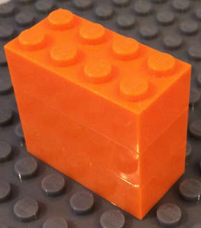

When the shape is decomposed, the layers are separated to show three layers, each with volume 2 x 4 x 1 = 8 studs3. Three layers gives the total volume of the rectangular prism as

3 x 8 = 24 studs3.

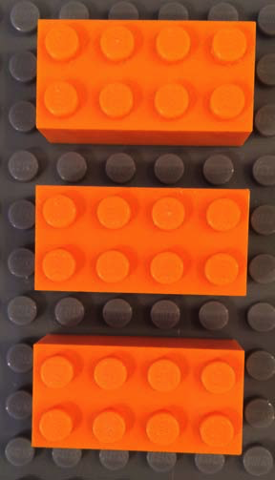

4. Answers will vary based on the bricks chosen for the model in #3. Using the example illustrated for #3, and doubling the width dimension from 2 to 4, the answer would be:

Rectangular prism of dimensions 4 x 4 x 3

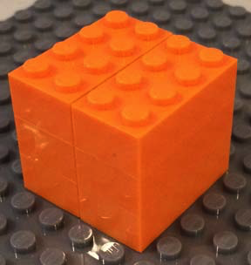

When the shape is decomposed, the layers are separated to show three layers, each with volume 4 x 4 x 1 = 16 studs3. Three layers gives the total volume of the rectangular prism as

3 x 16 = 48 studs3.

